Name: Christian Alvarez
Date: October 19, 2025
Class: IT2249
Unit: U2A1
Source Code
1. package u2a1_addmultiplythreeints;
2. /**
3. * @date 10/13/2025
4. * @author Christian Alvarez
5. *
6. * Adding and Multiplying integers
7. */
8.
9. // import Scanner class
10. import java.util.Scanner;
11.
12. public class U2A1_AddMultiplyThreeInts {
13.
14. // use a function to get the sum and product of the integers
15. // adding function
16. public static int intsSum(int int1, int int2, int int3) {
17. // return the sum of the intagers
18. return (int1 + int2) + int3;
19. }
20.
21. // multiplying function
22. public static int intsProduct(int int1, int int2, int int3) {
23. // return the product of the integers
24. return (int1 * int2) * int3;
25. }
26.
27. //
28. public static void main(String[] args) {
29. // create scanner instance
30. Scanner scn = new Scanner(System.in);
31.
32. // prompt use for the three integers
33. System.out.print("Enter the first integer: ");
34. int userInt1 = scn.nextInt();
35.
36. System.out.print("Enter the second integer: ");
37. int userInt2 = scn.nextInt();
38.
39. System.out.print("Enter the third integer: ");
40. int userInt3 = scn.nextInt();
41.
42. // output product
43. System.out.printf("The sum of three integers = %d%n", intsSum(userInt1, userInt2, userInt3));
44.
45. // output sum
46. System.out.printf("The product of three integers = %d%n", intsProduct(userInt1, userInt2, userInt3));
47.
48. }
49. }
50.

Screenshots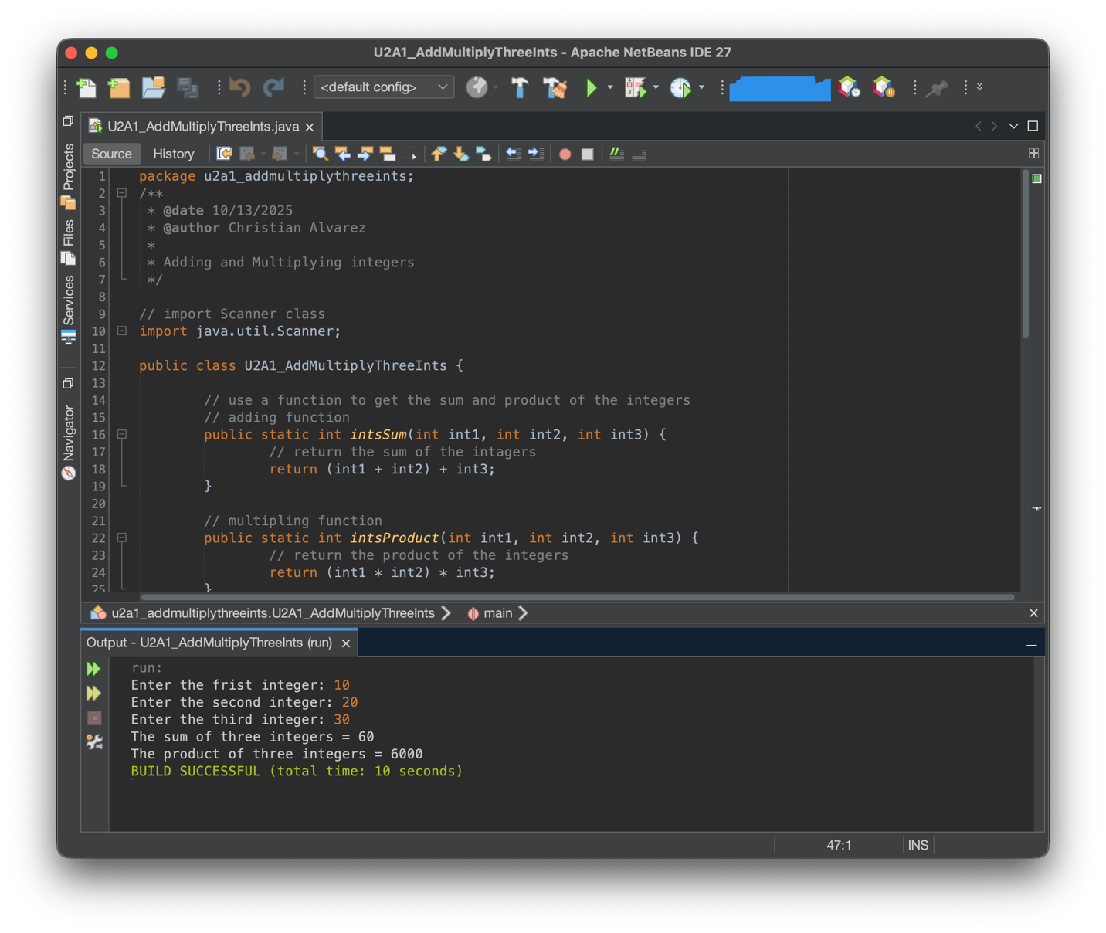
Explanation
This Java application asks users to enter three integers and then calculates both their sum and product. The program uses a modular design with two separate methods: intsSum() adds the three numbers together, while intsProduct() multiplies them. I chose to create these separate functions instead of doing calculations directly in main because it makes the code cleaner, easier to test, and reusable if needed elsewhere. Both methods are public and static so they can be called directly from the main method.
The program uses several important Java features. The Scanner class handles user input, arithmetic operators perform the calculations, and printf() displays formatted results. The flow is straightforward: create a Scanner, prompt for three integers one at a time, send values to the calculation methods, and print results. Testing confirmed the program works with positive numbers, negative values, zero, and combinations. This modular approach demonstrates core Java concepts like methods, user input, and arithmetic operations.

